Korea-UAE Joint R&D Technical Center (KUTC)

The KUTC was launched by KU and the Korea Basic Science Institute (KBSI), with support from the Korea Ministry of Science & ICT and UAE Abu Dhabi Department of Economic Development. It will initially cover areas including advanced materials especially in energy, oil and gas, and catalysts, as well as characterization of semiconductor materials and devices, in addition to materials for bio-medical and energy applications.

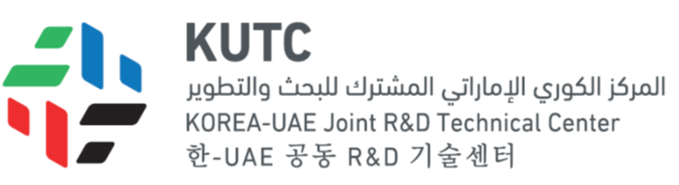

Ojjectives/Mission- 1. Support and upgrade UAE research infrastructure; 2. Facilitate collaborative R&D between UAE and Korea; 3. Develop scientific exchange hub in UAE; 4. Build joint research laboratories
Vision- Open research platform in UAE

